Hands-on Neural Networks – MNIST DATASET
- Installing and import the libraries.
- Loading the dataset.
- Let’s check the images for different digits.
f, axarr = plt.subplots(10,2,figsize=(10,20))
for i in range(10):
images = x_train[y_train==i]
axarr[i,0].imshow(images[0],cmap="grey")
axarr[i,1].imshow(images[1],cmap="gray")

axarr[i,0].axis('off')
axarr[i,1].axis('off')

axarr[i,0].set_title(str(i))
axarr[i,1].set_title(str(i))

plt.subplots_adjust(hspace=0.5)
plt.show()

4.Processing the data and after preparation for model.
Data scaling
- Previously, the range was [0,255]
- Now, the range after normalizing is [0,1]

Reshaping the input
We need to reshape the image data from (n,h,w) to (n,h∗w), where
- n = number of images in the dataset
- h = height of the image
- w = width of the image
For example, image data of dimension (50000,28,28) is transformed to (50000,28∗28), i.e., (50000,784).

MODEL 0
# clears the current Keras session, resetting all layers and models previously created, freeing up memory and resources.
tf.keras.backend.clear_session()
# initializing the neural network
model = Sequential()
# Adding a dense layer with softmax activation function, with the input dimension determined by the shape of the training data.
model.add(Dense(num_classes, activation = 'softmax', input_dim = x_train.shape[1]))

#Printing the summary.
model.summary()
batch_size = x_train.shape[0]
epochs = 10

# time.time() returns the time in seconds since Thu Jan 1 00:00:00 1970.
start = time.time()

# Fitting the model.
history = model.fit(
x_train, y_train,
validation_data=(x_val,y_val),
batch_size=batch_size,
epochs=epochs
)

# time.time() returns the time in seconds since Thu Jan 1 00:00:00 1970.
end = time.time()

Epoch 1/10
1/1 ━━━━━━━━━━━━━━━━━━━━ 2s 2s/step - accuracy: 0.0933 - loss: 2.3785 - val_accuracy: 0.1019 - val_loss: 2.3576
Epoch 2/10
1/1 ━━━━━━━━━━━━━━━━━━━━ 2s 2s/step - accuracy: 0.0996 - loss: 2.3633 - val_accuracy: 0.1081 - val_loss: 2.3429
Epoch 3/10
1/1 ━━━━━━━━━━━━━━━━━━━━ 1s 919ms/step - accuracy: 0.1053 - loss: 2.3485 - val_accuracy: 0.1159 - val_loss: 2.3286
Epoch 4/10
1/1 ━━━━━━━━━━━━━━━━━━━━ 1s 754ms/step - accuracy: 0.1115 - loss: 2.3342 - val_accuracy: 0.1224 - val_loss: 2.3148
Epoch 5/10
1/1 ━━━━━━━━━━━━━━━━━━━━ 1s 1s/step - accuracy: 0.1180 - loss: 2.3203 - val_accuracy: 0.1286 - val_loss: 2.3014
Epoch 6/10
1/1 ━━━━━━━━━━━━━━━━━━━━ 2s 2s/step - accuracy: 0.1244 - loss: 2.3068 - val_accuracy: 0.1342 - val_loss: 2.2882
Epoch 7/10
1/1 ━━━━━━━━━━━━━━━━━━━━ 1s 691ms/step - accuracy: 0.1313 - loss: 2.2936 - val_accuracy: 0.1408 - val_loss: 2.2755
Epoch 8/10
1/1 ━━━━━━━━━━━━━━━━━━━━ 1s 631ms/step - accuracy: 0.1380 - loss: 2.2807 - val_accuracy: 0.1480 - val_loss: 2.2630
Epoch 9/10
1/1 ━━━━━━━━━━━━━━━━━━━━ 1s 676ms/step - accuracy: 0.1455 - loss: 2.2682 - val_accuracy: 0.1554 - val_loss: 2.2508
Epoch 10/10
1/1 ━━━━━━━━━━━━━━━━━━━━ 1s 1s/step - accuracy: 0.1527 - loss: 2.2559 - val_accuracy: 0.1628 - val_loss: 2.2388

print ("Time taken in seconds ",end-start)
Time taken in seconds 11.258029460906982

#Plot the graph
plot(history,'loss')

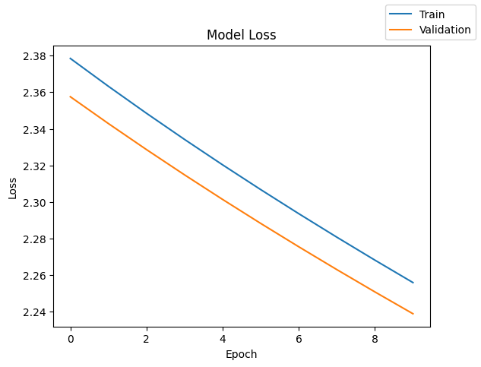

plot(history,'accuracy')
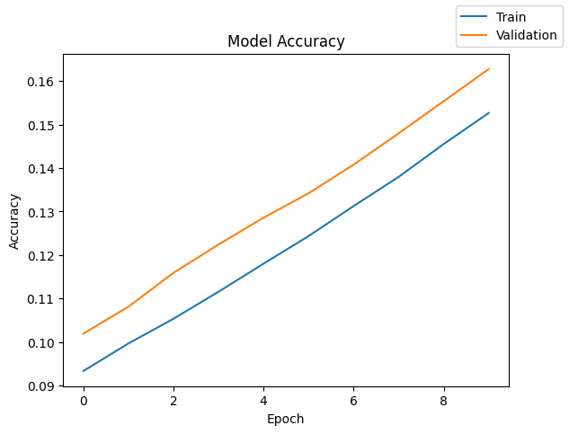

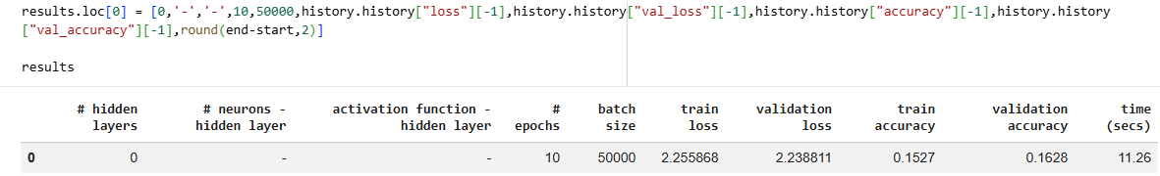

MODEL 1
batch_size = x_train.shape[0]
epochs = 50 ----CHANGE THE EPOCHS SIZE
model.compile(loss="categorical_crossentropy", optimizer="sgd", metrics=["accuracy"])
print("Time taken in seconds ",end-start)
Time taken in seconds 29.394503355026245
plot(history,'loss')
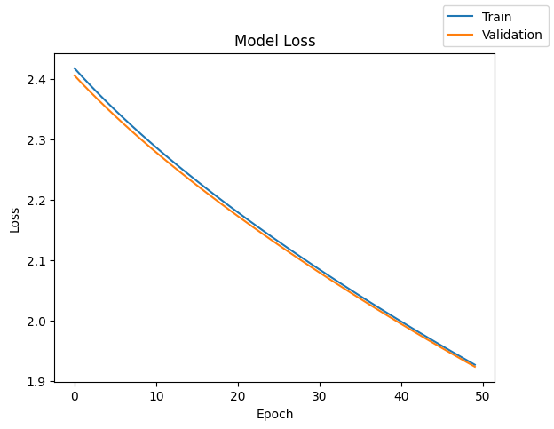

plot(history,'accuracy')
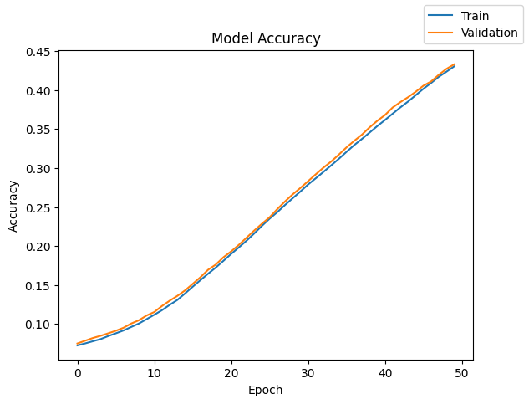
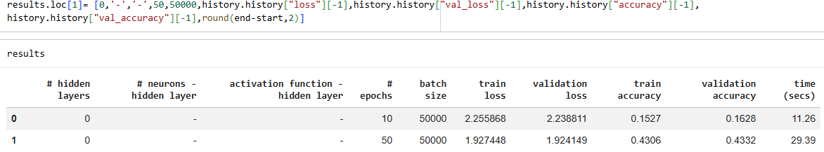

MODEL 2
batch_size = 32 --CHANGE THE BACH
epochs = 10
model.compile(loss="categorical_crossentropy", optimizer="sgd", metrics=["accuracy"])

print("Time taken in seconds ",end-start)
Time taken in seconds 61.77246928215027

plot(history,'loss')
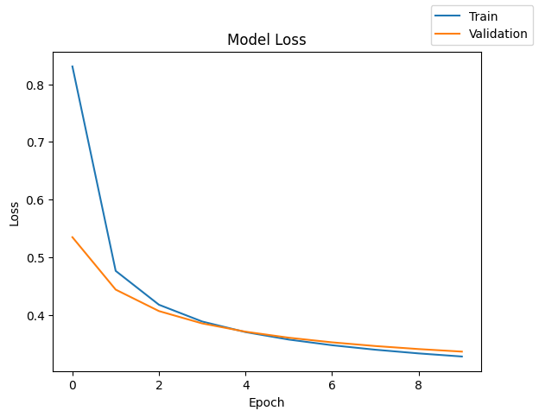

plot(history,'accuracy')
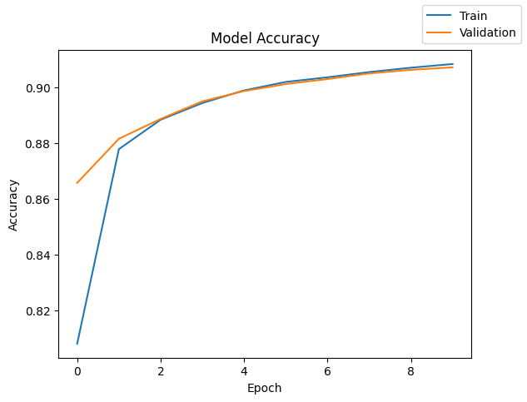

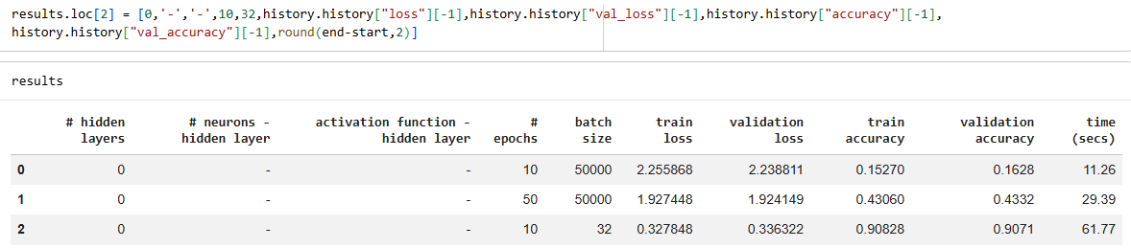

MODEL 3
batch_size = 32
epochs = 50 ----CHANGE THE EPOCHS
model.compile(loss="categorical_crossentropy", optimizer="sgd", metrics=["accuracy"])

print("Time taken in seconds ",end-start)
Time taken in seconds 215.35317420959473
plot(history,'loss')
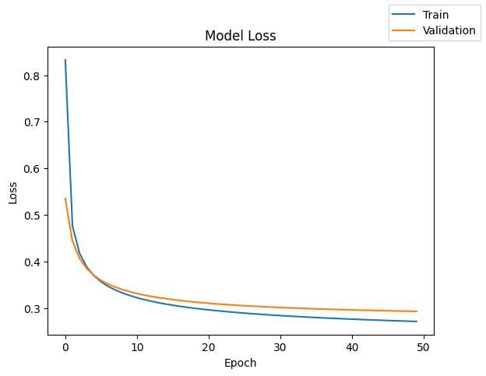

plot(history,'accuracy')
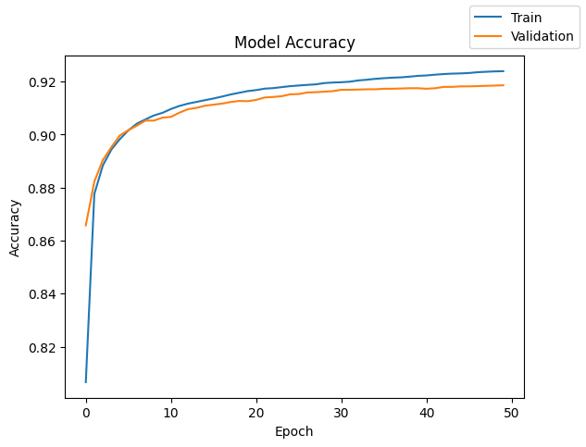

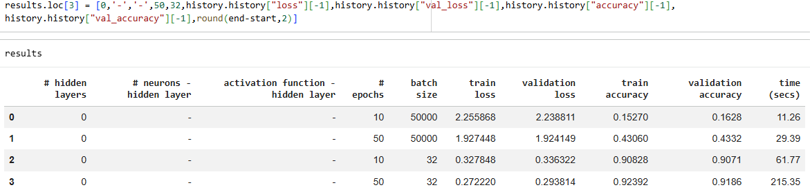

MODEL 4
batch_size = 64 ---CHANGE THE BATCH SIZE
epochs = 50
model.compile(loss="categorical_crossentropy", optimizer="sgd", metrics=["accuracy"])

print("Time taken in seconds ",end-start)
Time taken in seconds 115.7985475063324

plot(history,'loss')
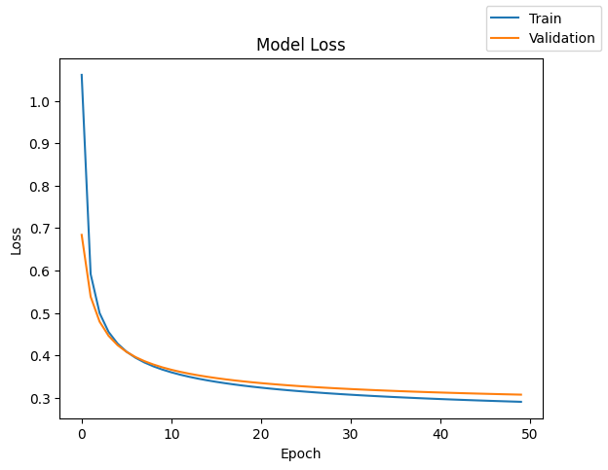

plot(history,'accuracy')
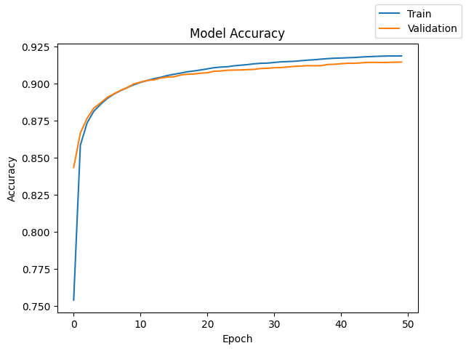

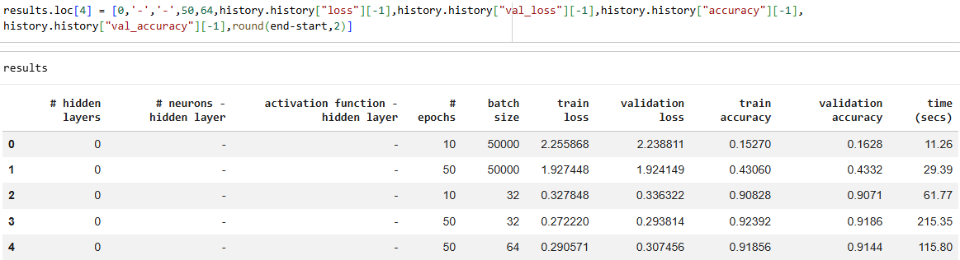

MODEL 5
#Initializing the neural network
model = Sequential()
model.add(Dense(64,activation='sigmoid',input_dim = x_train.shape[1]))
----ADD ACTIVATION FUNCTION
model.add(Dense(num_classes, activation = 'softmax')--HIDDEN LAYER 1

batch_size = x_train.shape[0]
epochs = 50 ---CHANGE THE BATCH SIZE AND EPOCHS
model.compile(loss="categorical_crossentropy", optimizer="sgd", metrics=["accuracy"])

print("Time taken in seconds ",end-start)
Time taken in seconds 36.02716112136841
plot(history,'loss')
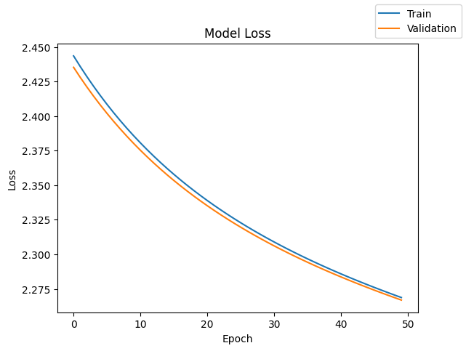

plot(history,'accuracy')
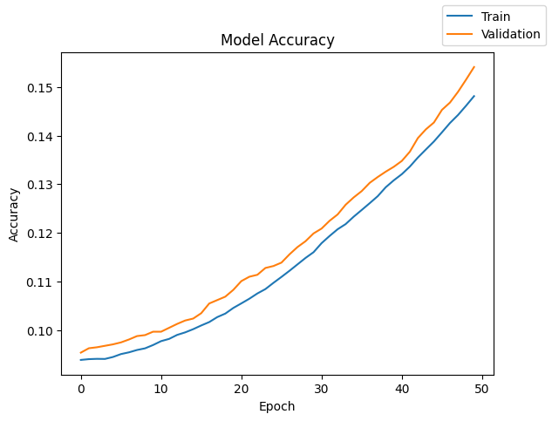
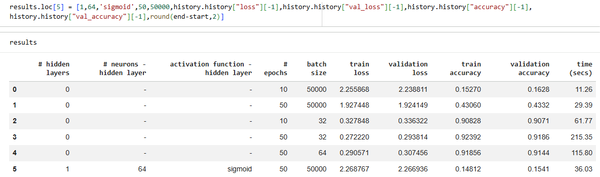

MODEL 6
#Initializing the neural network
model = Sequential()
model.add(Dense(64,activation='sigmoid',input_dim = x_train.shape[1]))
model.add(Dense(num_classes, activation = 'softmax'))
batch_size = 32 ---CHANGE THE BATCH SIZE
epochs = 50
model.compile(loss="categorical_crossentropy", optimizer="sgd", metrics=["accuracy"])

print("Time taken in seconds ",end-start)
Time taken in seconds 277.1810963153839

plot(history,'loss')
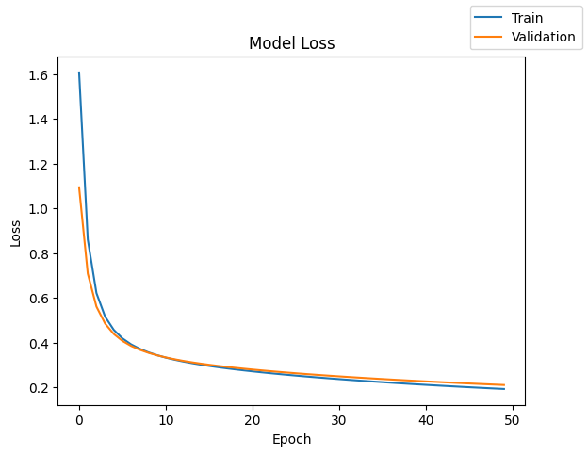

plot(history,'accuracy')
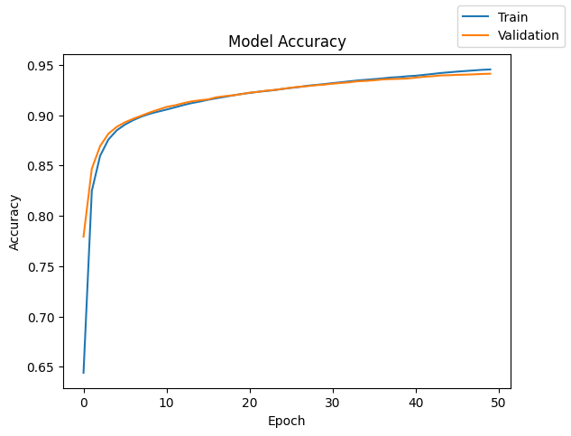

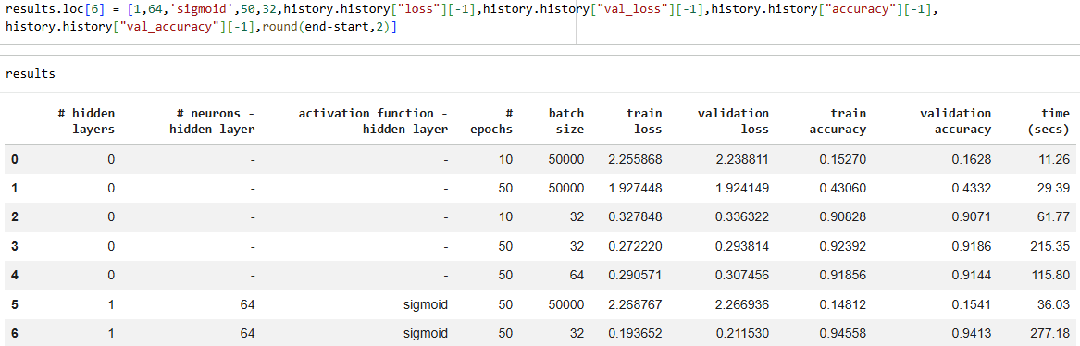

MODEL 7
model.add(Dense(128, activation = 'sigmoid', input_dim = x_train.shape[1])) --CHANGE THE HIDDEN LAYER
model.add(Dense(num_classes, activation = 'softmax'))
model.summary()
model.compile(loss="categorical_crossentropy", optimizer="sgd", metrics=["accuracy"])
batch_size = 32
epochs = 50
start = time.time()
history = model.fit(x_train, y_train, validation_data=(x_val,y_val) , batch_size=batch_size, epochs=epochs)
end = time.time()

print("Time taken in seconds ",end-start)
Time taken in seconds 362.516410112381
plot(history,'loss')
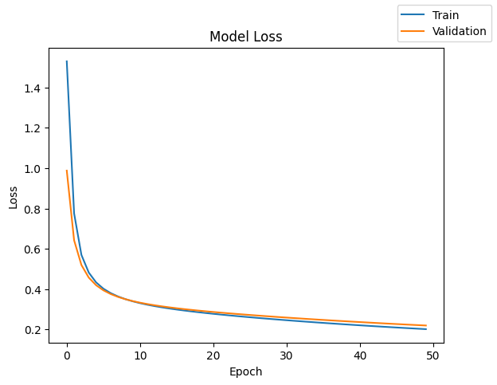

plot(history,'accuracy')
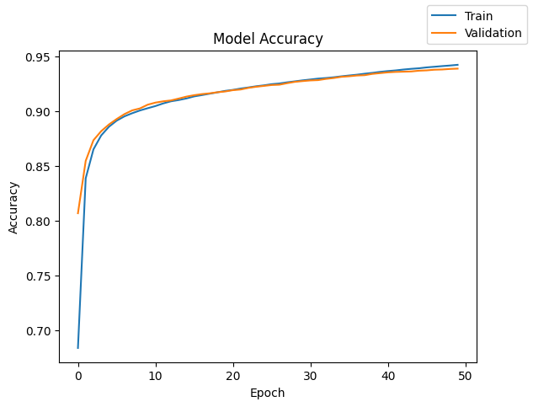

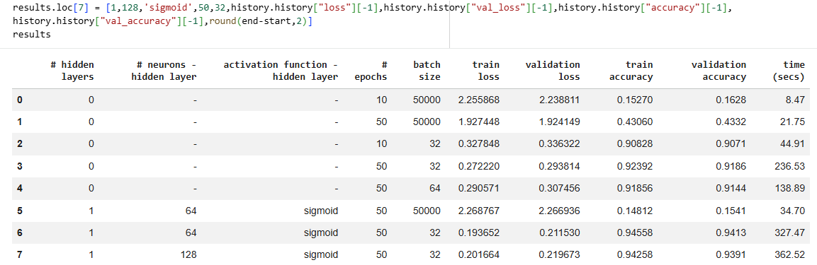

MODEL 8
model.add(Dense(128, activation = 'tanh', input_dim = x_train.shape[1])) --CHANGE THE ACTIVATION FUNCTION
model.add(Dense(num_classes, activation = 'softmax'))
model.summary()
model.compile(loss="categorical_crossentropy", optimizer="sgd", metrics=["accuracy"])
batch_size = 32
epochs = 50
start = time.time()
history = model.fit(x_train, y_train, validation_data=(x_val,y_val) , batch_size=batch_size, epochs=epochs)
end = time.time()

print("Time taken in seconds ",end-start)
Time taken in seconds 391.0994200706482

plot(history,'loss')
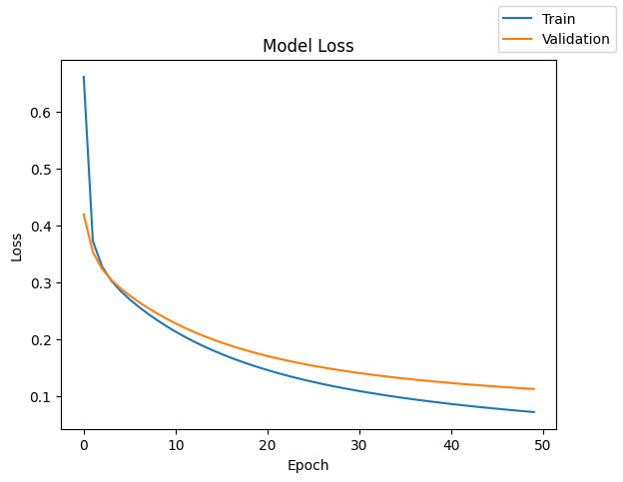

plot(history,'accuracy')

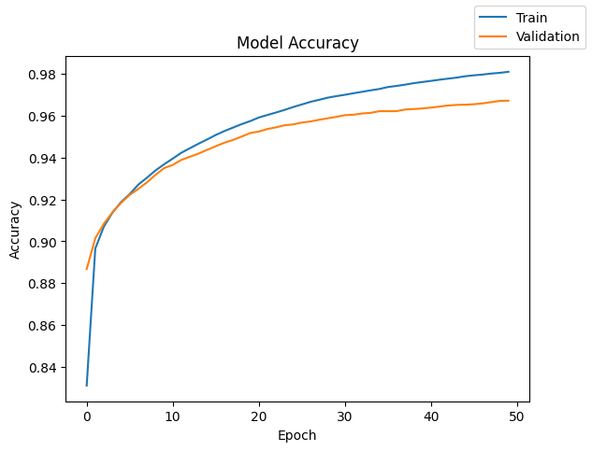

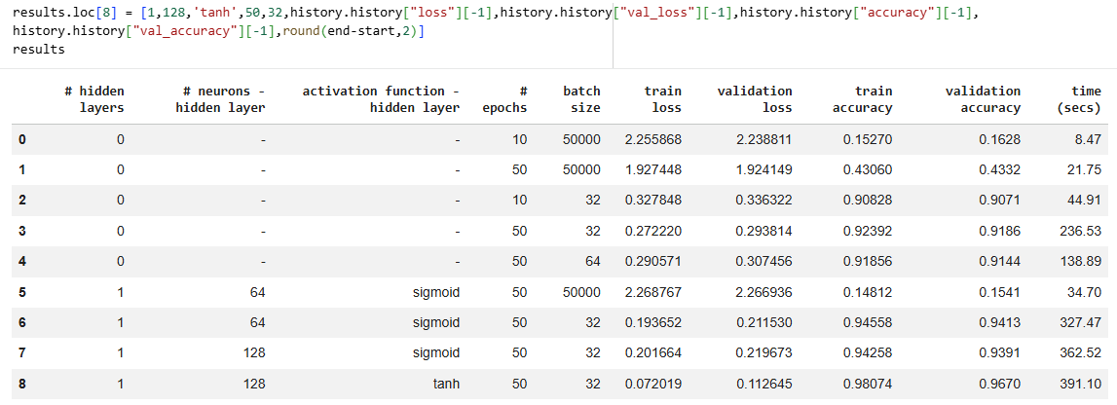

MODEL 9
model.add(Dense(128, activation = 'relu', input_dim = x_train.shape[1])) --CHANGE THE ACTIVATION FUNCTION
model.add(Dense(num_classes, activation = 'softmax'))
model.summary()
model.compile(loss="categorical_crossentropy", optimizer="sgd", metrics=["accuracy"])
batch_size = 32
epochs = 50
start = time.time()
history = model.fit(x_train, y_train, validation_data=(x_val,y_val) , batch_size=batch_size, epochs=epochs)
end = time.time()

print("Time taken in seconds ",end-start)
Time taken in seconds 386.2304494380951
lot(history,'loss')
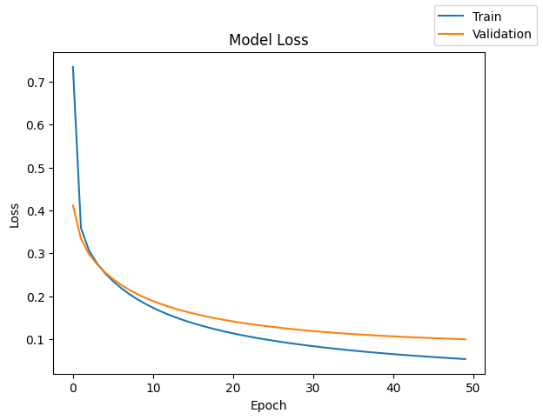

plot(history,'accuracy')
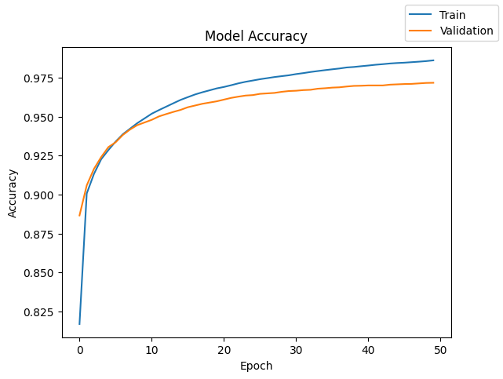

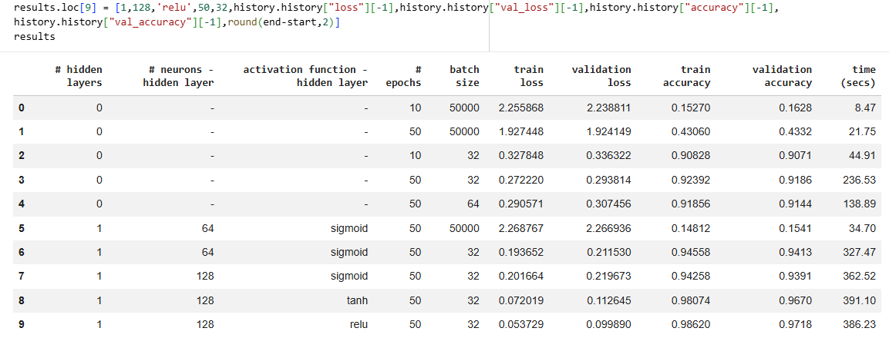

MODEL 10
model.add(Dense(128, activation = 'relu', input_dim = x_train.shape[1]))
model.add(Dense(64,activation='tanh'))--HIDDEN LAYER 1
model.add(Dense(num_classes, activation = 'softmax'))--ADD HIDDEN LAYER 2
model.summary()
model.compile(loss="categorical_crossentropy", optimizer="sgd", metrics=["accuracy"])
batch_size = 32
epochs = 50
start = time.time()
history = model.fit(x_train, y_train, validation_data=(x_val,y_val) , batch_size=batch_size, epochs=epochs)
end = time.time()

print("Time taken in seconds ",end-start)

Time taken in seconds 392.44478583335876

plot(history,'loss')
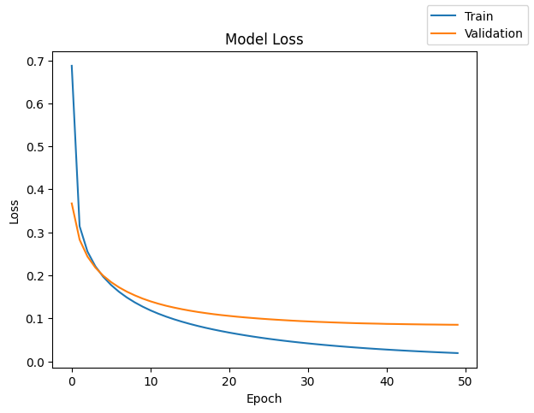

plot(history,'accuracy')
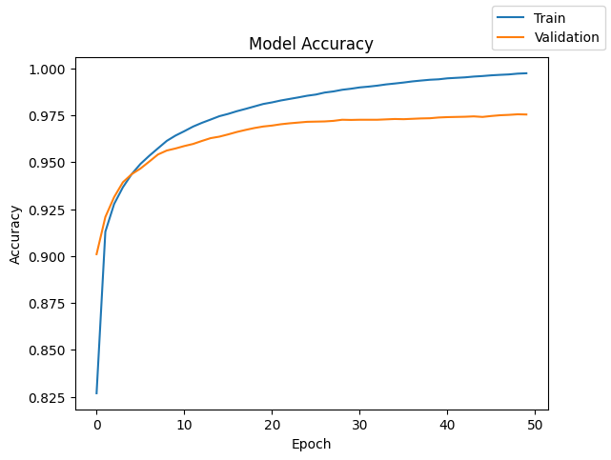

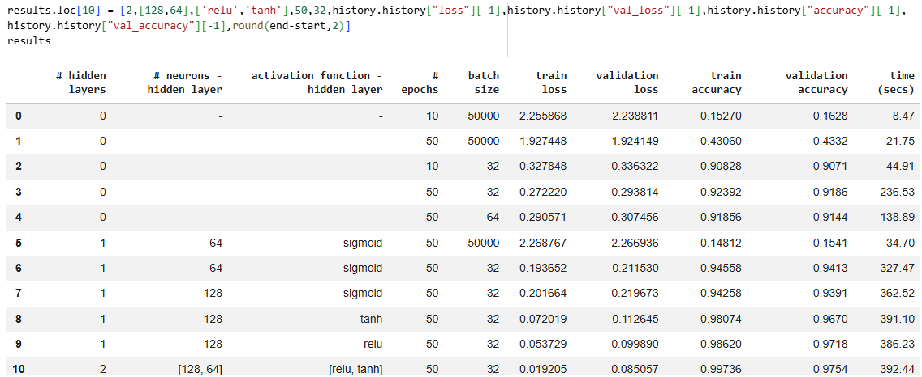

MODEL 11
tf.keras.backend.clear_session()
model = Sequential()
model.add(Dense(128, activation = 'tanh', input_dim = x_train.shape[1]))
model.add(Dense(64,activation='relu')) --CHANGE THE ACTIVATION FUNCTION
model.add(Dense(num_classes, activation = 'softmax'))
model.summary()
model.compile(loss="categorical_crossentropy", optimizer="sgd", metrics=["accuracy"])
batch_size = 32
epochs = 50
start = time.time()
history = model.fit(x_train, y_train, validation_data=(x_val,y_val) , batch_size=batch_size, epochs=epochs)
end = time.time()

print("Time taken in seconds ",end-start)
Time taken in seconds 370.5833909511566

plot(history,'loss')
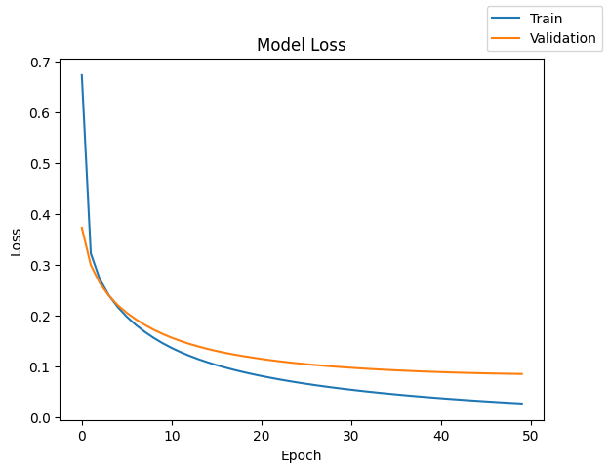

plot(history,'accuracy')
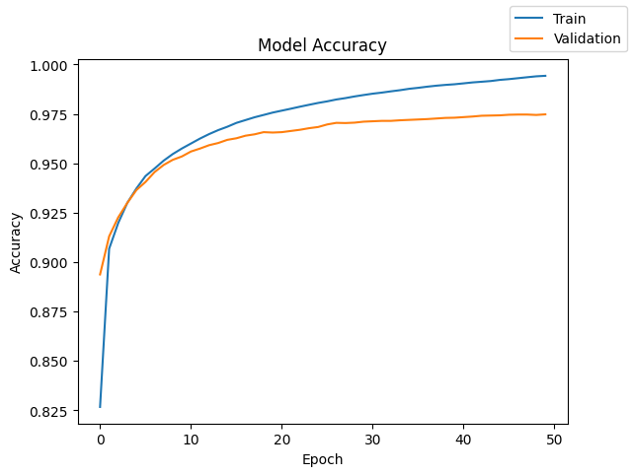

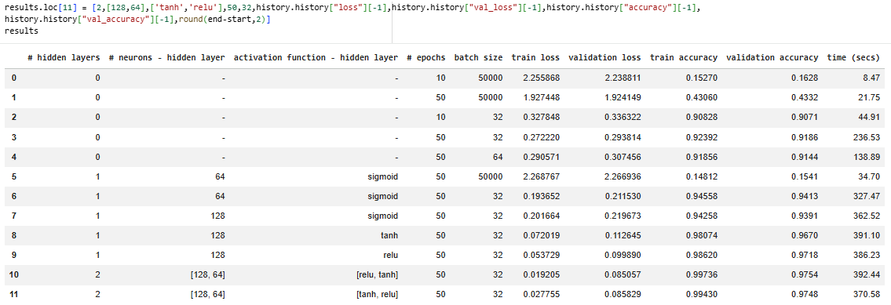

MODEL 12
model.add(Dense(128,activation='relu',input_dim = x_train.shape[1]))
--HIDDEN LAYER 1
model.add(Dense(64,activation='relu')) ---HIDDEN LAYER 2
model.add(Dense(32,activation='relu')) ---HIDDEN LAYER 3
model.add(Dense(num_classes, activation = 'softmax'))
model.summary()
model.compile(loss="categorical_crossentropy", optimizer="sgd", metrics=["accuracy"])
batch_size = 32
epochs = 50
start = time.time()
history = model.fit(x_train, y_train, validation_data=(x_val,y_val) , batch_size=batch_size, epochs=epochs)
end = time.time()

print("Time taken in seconds ",end-start)
Time taken in seconds 382.59454584121704
plot(history,'loss')
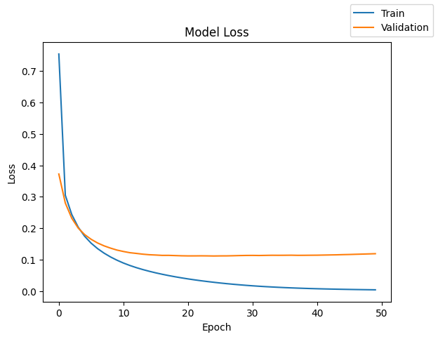

plot(history,'accuracy')
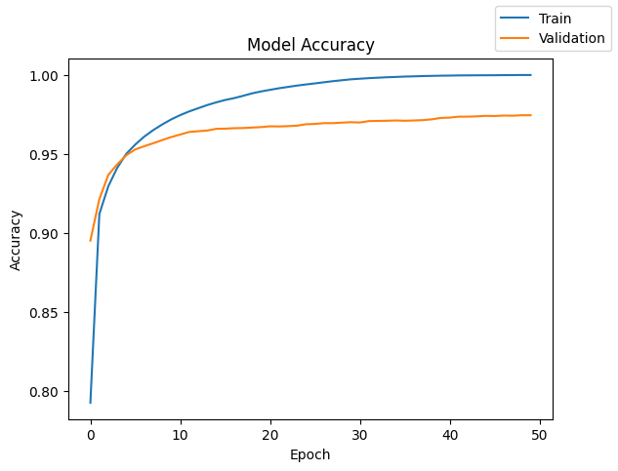

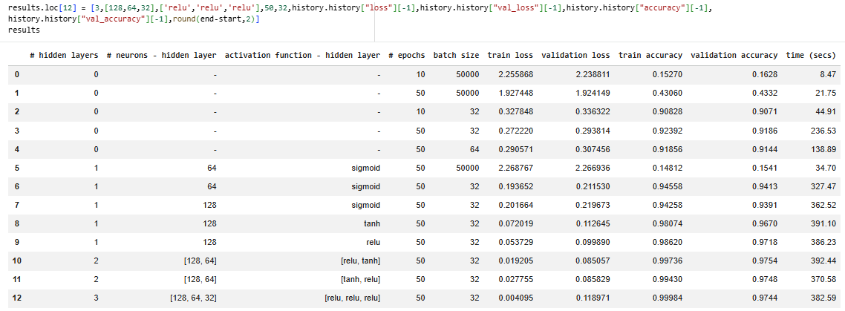

MODEL 13
tf.keras.backend.clear_session()
model = Sequential()
model.add(Dense(128,activation='relu',input_dim = x_train.shape[1]))
model.add(Dense(64,activation='relu'))
model.add(Dense(32,activation='relu'))
model.add(Dense(num_classes, activation = 'softmax'))
model.summary()
model.compile(loss="categorical_crossentropy", optimizer="sgd", metrics=["accuracy"])
batch_size = 32
epochs = 100 ---CHANGE THE EPOCH SIZE
start = time.time()
history = model.fit(x_train, y_train, validation_data=(x_val,y_val) , batch_size=batch_size, epochs=epochs)
end = time.time()

print("Time taken in seconds ",end-start)
Time taken in seconds 767.018522977829

plot(history,'loss')
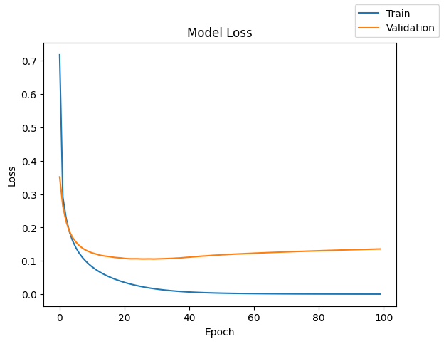

plot(history,'accuracy')
